Ethernet NIC

🧩 What is an Ethernet NIC?
# Source: Chatgpt (GPT‑5 Mini) at [12/18/2025]
An Ethernet NIC (Network Interface Card) is a hardware component that allows a computer or networked device to connect to a wired Ethernet network. It provides the physical port (usually an RJ-45 jack) and the circuitry to transmit and receive data over Ethernet cables (e.g., Cat5e, Cat6).
✅ An Ethernet NIC is what enables your desktop, laptop, or server to connect to a LAN (Local Area Network) using a cable.

🔌 How It Works
# Source: Chatgpt (GPT‑5 Mini) at [12/18/2025]
The Ethernet NIC:
- Accepts data from the computer’s system bus (via PCIe, USB, etc.)
- Converts it into Ethernet frames
- Sends it over the Ethernet cable to the switch/router
- Listens for incoming data, processes it, and delivers it to the system

🔧 Key Features of Ethernet NICs
# Source: Chatgpt (GPT‑5 Mini) at [12/18/2025]
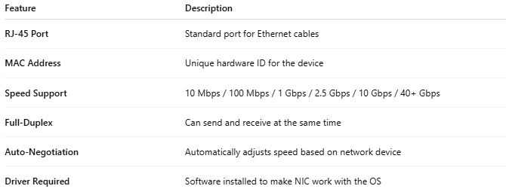

Feature | Description
RJ-45 Port | Standard port for Ethernet cables
MAC Address | Unique hardware ID for the device
Speed Support | 10 Mbps / 100 Mbps / 1 Gbps / 2.5 Gbps / 10 Gbps / 40+ Gbps
Full-Duplex | Can send and receive at the same time
Auto-Negotiation | Automatically adjusts speed based on network device
Driver Required | Software installed to make NIC work with the OS

📦 Form Factors
# Source: Chatgpt (GPT‑5 Mini) at [12/18/2025]
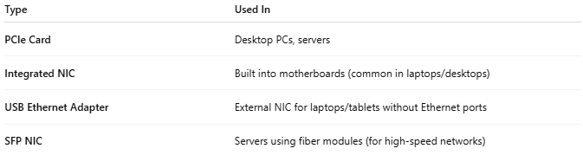

Type | Used In
PCIe Card | Desktop PCs, servers
Integrated NIC | Built into motherboards (common in laptops/desktops)
USB Ethernet Adapter | External NIC for laptops/tablets without Ethernet ports
SFP NIC | Servers using fiber modules (for high-speed networks)

🧠 Where It Operates
# Source: Chatgpt (GPT‑5 Mini) at [12/18/2025]
- OSI Layer 1 (Physical Layer) – Deals with electrical signals over cables
- OSI Layer 2 (Data Link Layer) – Handles MAC addressing and Ethernet framing

✅ Advantages
# Source: Chatgpt (GPT‑5 Mini) at [12/18/2025]
- ✅ Stable and fast connection (no wireless interference)
- ✅ Low latency — great for gaming and video conferencing
- ✅ Higher bandwidth than most wireless connections
- ✅ Supports VLANs and advanced features in managed networks

❌ Disadvantages
# Source: Chatgpt (GPT‑5 Mini) at [12/18/2025]
- ❌ Requires physical cabling
- ❌ Less mobility (tethered to network ports)
- ❌ May require driver installation or updates

🧪 Example
# Source: Chatgpt (GPT‑5 Mini) at [12/18/2025]
If your computer has an IP address like 192.168.1.100 and connects via a cable to your router — that's your Ethernet NIC in action.

📌 Summary
# Source: Chatgpt (GPT‑5 Mini) at [12/18/2025]
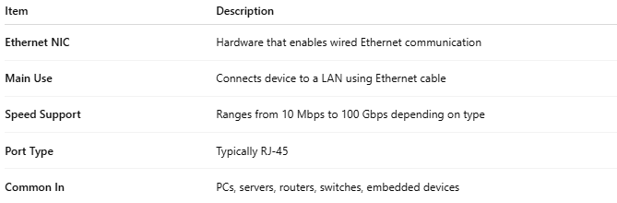

Item | Description
Ethernet NIC | Hardware that enables wired Ethernet communication
Main Use | Connects device to a LAN using Ethernet cable
Speed Support | Ranges from 10 Mbps to 100 Gbps depending on type
Port Type | Typically RJ-45
Common In | PCs, servers, routers, switches, embedded devices

